**­­­**

**GUJARAT UNIVERSITY**



**DEPARTMENT OF STATISTICS**

**SCHOOL OF SCIENCES,**

**GUJARAT UNIVERSITY,**

**AHMEDABAD**

**2021 – 2022**

**GUJARAT UNIVERSITY**

**AHMEDABAD**



**2021-2022**

Project Report On

**Suicides in India**

Submitted By

**Piyush Katariya & Gaurav Jha**

**Roll No. 17 & 16**

Guided By

**Dr. Pravinder Singh**

Professor

Department of Statistics,

School of Sciences, Gujarat University, Ahmedabad.

**GUJARAT UNIVERSITY**

**AHMEDABAD**



**DEPARTMENT OF STATISTICS**

**SCHOOL OF SCIENCES**

**2021-2022**

**CERTIFICATE**

This is to certify that Mr. Piyush Katariya has submitted his project report entitled “**Suicides in India”**. This project has been guided by Dr. Pravinder, Professor, Department of Statistics, School of Sciences, Gujarat University, Ahmedabad and the signature which appear below have been given after final approval with reference to its contents and form. This report is an acceptance of successful completion of project report.

**Guide HOD**

|  |  |
| --- | --- |
| **Dr. Pravinder**  **Professor**  **Department of Statistics**  **School of Sciences,**  **Gujarat University,**  **Ahmedabad.** | **Dr. C D Bhavsar**  **Prof. and HOD**  **Department of Statistics**  **School of Sciences,**  **Gujarat University,**  **Ahmedabad.** |

**GUJARAT UNIVERSITY**

**AHMEDABAD**



**DEPARTMENT OF STATISTICS**

**SCHOOL OF SCIENCES**

**2021-2022**

**CERTIFICATE**

This is to certify that Mr. Gaurav Jha has submitted his project report entitled “**Suicides in India”**. This project has been guided by Dr. Pravinder, Professor, Department of Statistics, School of Sciences, Gujarat University, Ahmedabad and the signature which appear below have been given after final approval with reference to its contents and form. This report is an acceptance of successful completion of project report.

**Guide HOD**

|  |  |
| --- | --- |
| **Dr. Pravinder**  **Professor**  **Department of Statistics**  **School of Sciences,**  **Gujarat University,**  **Ahmedabad.** | **Dr. C D Bhavsar**  **Prof. and HOD**  **Department of Statistics**  **School of Sciences,**  **Gujarat University,**  **Ahmedabad.** |

# **TABLE OF CONTENTS**:

# Introduction

# Suicides in world

# Suicides in India

# Introduction of our data

# Suicide Rate

# Statistical Analysis of Suicide data of India from 2001-2012

# Suicide rate of India every year

# State wise suicide rate of 2011

# Gender wise analysis of suicide

# F-test, T-test, Graph

# Education Status vs Suicide count

# ANOVA-Single factor, Graph

# Age Group vs Year wise analysis

# ANOVA-Two factor, Causes charts

# Causes vs Suicides

# State wise Causes

# Profession vs Suicides

# Social status vs Suicides

# Forecasting based on Trendline

# Source of information

# INTRODUCTION

*“Suicide is the act of intentionally causing one's own death.”*

# SUICIDE IN WORLD

According to the WHO

Close to 800 000 people die due to suicide every year, which is one person every 40 seconds. Suicide is a global phenomenon and occurs throughout the lifespan. Effective and evidence-based interventions can be implemented at population, sub-population and individual levels to prevent suicide and suicide attempts. There are indications that for each adult who died by suicide there may have been more than 20 others attempting suicide.

Some suicides are impulsive acts due to stress, such as from financial difficulties, relationship problems such as breakups, or bullying. Those who have previously attempted suicide are at a higher risk for future attempts. Effective suicide prevention efforts include limiting access to methods of suicide—such as firearms, drugs, and poisons; treating mental disorders and substance misuse; careful media reporting about suicide; and improving economic conditions. Approximately 1.5% of people die by suicide. In a given year this is roughly 12 per 100,000 people. Rates of completed suicides are generally higher among men than among women, ranging from 1.5 times as much in the developing world to 3.5 times in the developed world. Suicide is generally most common among those over the age of 70; however, in certain countries, those aged between 15 and 30 are at the highest risk. Europe had the highest rates of suicide by region in 2015. There are an estimated 10 to 20 million non-fatal attempted suicides every year. Non-fatal suicide attempts may lead to injury and long-term disabilities. In the Western world, attempts are more common among young people and among females.

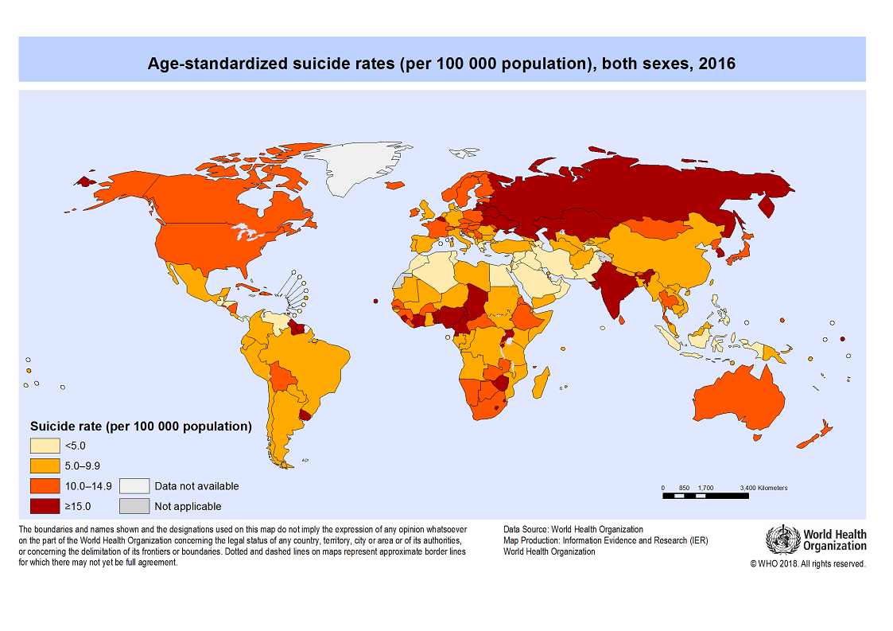

The given map of world suicide is taken from the official website of World Health Organization (WHO) .It is clearly visible from the above representation that eastern countries have higher level of suicide as compared to western countries. Among eastern countries, Asian countries have highest suicide rate and India is one of the prominent country in that list.

* **From the given below graphical presentation, we can conclude that India has highest number of suicide rate in female.**

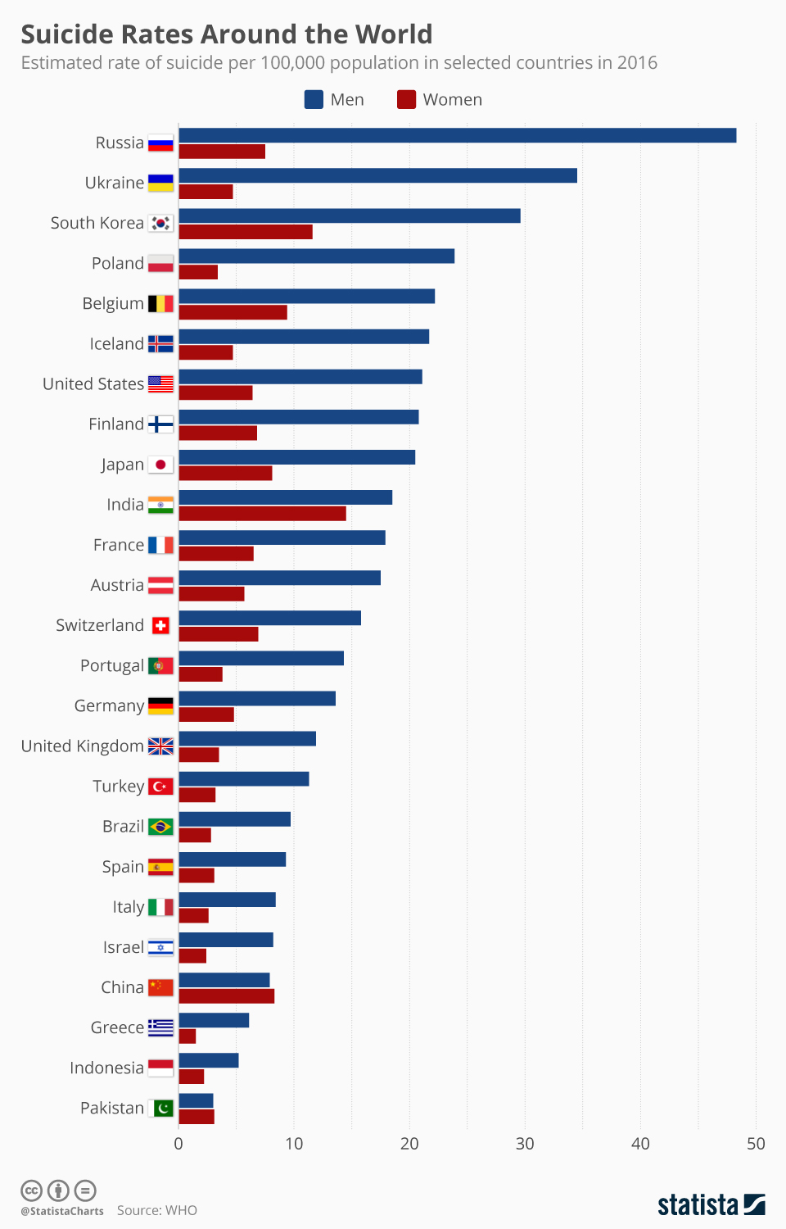

## **SUICIDES IN INDIA**

In 2016 the number of suicides in India had increased to 230,314. Suicide was the most common cause of death in both the age groups of 15–29 years and 15–39 years.

About 800,000 people die by suicide worldwide every year, of these 135,000 (17%) are residents of India, a nation with 17.5% of world population. Between 1987 and 2007, the suicide rate increased from 7.9 to 10.3 per 100,000, with higher suicide rates in southern and eastern states of India. In 2012, Tamil Nadu (12.5% of all suicides), Maharashtra (11.9%) and West Bengal (11.0%) had the highest proportion of suicides. Among large population states, Tamil Nadu and Kerala had the highest suicide rates per 100,000 people in 2012. The male to female suicide ratio has been about 2:1.

Here we have analysed the suicide data of India from 2001 to 2012

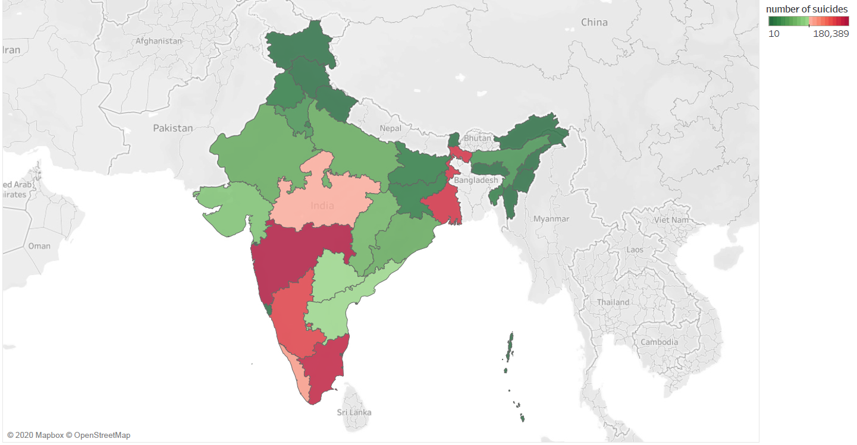

## **Introduction of our data**

# **Context**

This data set contains yearly suicide detail of all the states/u.t of India by various parameters from 2001 to 2012.

# **Content**

Time Period: 2001 - 2012

Granularity: Yearly

Location: States and U. T’s of India

# **Parameters:**

a) Suicide causes

b) Education status

c) By means adopted

d) Professional profile

e) Social status

# **Acknowledgements**

National Crime Records Bureau (NCRB), Govt of India has shared this dataset under Govt. Open Data License - India.

NCRB has also shared the historical data on their website

# **Columns**

State - States/UT's of India

Year - Year

Type_code - Major Type

Type - Minor Type

Gender - M/F

Age_group - Age Group

Total - Total No. of suicides

# **SUICIDE RATE**

Suicide rates are defined as the deaths deliberately initiated and performed by a person in the full knowledge or expectation of its fatal outcome. This indicator is presented as a total and per gender and is measured in terms of deaths per 100 000 inhabitants (total), per 100 000 men and per 100 000 women.

# **STATISTICAL ANALYSIS OF SUICIDE DATA OF INDIA FROM 2001-2012**

# **SUICIDE RATE OF INDIA EVERY YEAR**

|  |  |  |  |  |
| --- | --- | --- | --- | --- |
| **Year** | **Total Population** | **Total No. of Suicide** | **Suicide Rate** | |
| 2001 | 1028737436 | 108506 | 10.54749212 |  |
| 2002 | 1045547000 | 110417 | 10.56069215 |  |
| 2003 | 1062388000 | 110851 | 10.43413517 |  |
| 2004 | 1079117000 | 113697 | 10.53611425 |  |
| 2005 | 1095722000 | 113914 | 10.39625014 |  |
| 2006 | 1112186000 | 118112 | 10.6198064 |  |
| 2007 | 1128521000 | 122637 | 10.8670552 |  |
| 2008 | 1144734000 | 125017 | 10.9210524 |  |
| 2009 | 1160813000 | 127151 | 10.95361613 |  |
| 2010 | 1176742000 | 134599 | 11.43827619 |  |
| 2011 | 1210854977 | 135585 | 11.19745986 |  |
| 2012 | 1226596092 | 135445 | 11.04234727 |  |

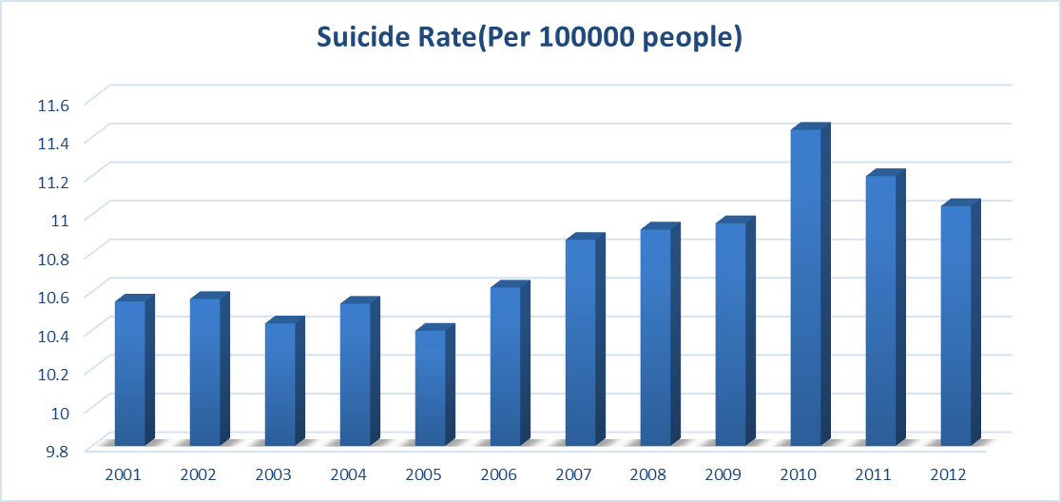

The above table and graph shows the suicide rate of India from year 2001 to 2012 with the reference of total population of the country in those years.

The below given table and graph shows the comparison of the suicide data of India from year 2001-2012 gender wise. The table given here has also taken the total population of male and female of those years into consideration. It is evident from the data that number of male committing suicide is double as compared to number of females for almost every year.



|  |
| --- |
| Source of Population data: Office of the Registrar General & Census Commissioner, India |
| Note: Values for the year 2001 & 2011 are originals values and values for remaining year are projected values by Census of India. |
| Note: Annual population growth rate during the year 2011 was 1.3%(source- world bank) so the estimated population for the year 2012 is 1226596092 |

Rate = Per 100000 people

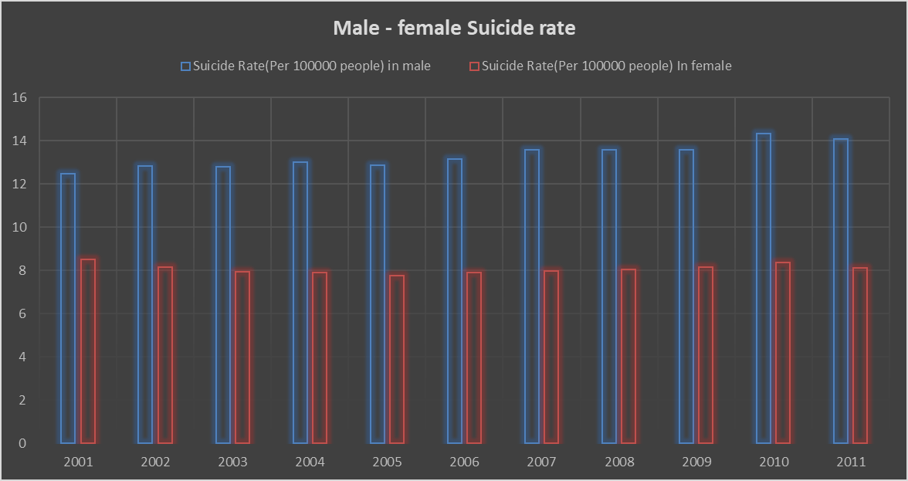

# STATE WISE SUICIDE RATE OF 2011

|  |  |  |  |
| --- | --- | --- | --- |
| **States** | **Total**  **Population (2011)** | **Total Suicide (2011)** | **Suicide Rate** |
| A & N Islands | 380581 | 136 | 35.734837 |
| Andhra Pradesh | 84580777 | 15077 | 17.82556337 |
| Arunachal Pradesh | 1383727 | 134 | 9.683991134 |
| Assam | 31205576 | 2726 | 8.735618275 |
| Bihar | 104099452 | 795 | 0.763692781 |
| Chandigarh | 1055450 | 105 | 9.948363257 |
| Chhattisgarh | 25545198 | 6756 | 26.44724069 |
| D & N Haveli | 343709 | 63 | 18.32945893 |
| Daman & Diu | 243247 | 33 | 13.56645714 |
| Delhi (Ut) | 16787941 | 1716 | 10.22162277 |
| Goa | 1458545 | 293 | 20.08851287 |
| Gujarat | 60439692 | 6382 | 10.55928611 |
| Haryana | 25351462 | 3245 | 12.80005074 |
| Himachal Pradesh | 6864602 | 443 | 6.453396715 |
| Jammu & Kashmir | 12541302 | 287 | 2.288438633 |
| Jharkhand | 32988134 | 1212 | 3.674048371 |
| Karnataka | 61095297 | 12622 | 20.65952802 |
| Kerala | 33406061 | 8431 | 25.23793512 |
| Lakshadweep | 64473 | 0 | 0 |
| Madhya Pradesh | 72626809 | 9259 | 12.7487358 |
| Maharashtra | 112374333 | 15947 | 14.19096298 |
| Manipur | 2855794 | 33 | 1.155545533 |
| Meghalaya | 2966889 | 153 | 5.156916892 |
| Mizoram | 1097206 | 90 | 8.20265292 |
| Nagaland | 1978502 | 33 | 1.667928564 |
| Odisha | 41974218 | 5241 | 12.48623619 |
| Puducherry | 1247953 | 557 | 44.63309115 |
| Punjab | 27743338 | 966 | 3.481916992 |
| Rajasthan | 68548437 | 4348 | 6.342960088 |
| Sikkim | 610577 | 184 | 30.13542927 |
| Tripura | 3673917 | 703 | 19.13489064 |
| Uttar Pradesh | 199812341 | 4843 | 2.423774215 |
| Uttarakhand | 10086292 | 317 | 3.142879465 |
| West Bengal | 91276115 | 16492 | 18.06825367 |
| Tamil Nadu | 72147030 | 15963 | 22.12565091 |

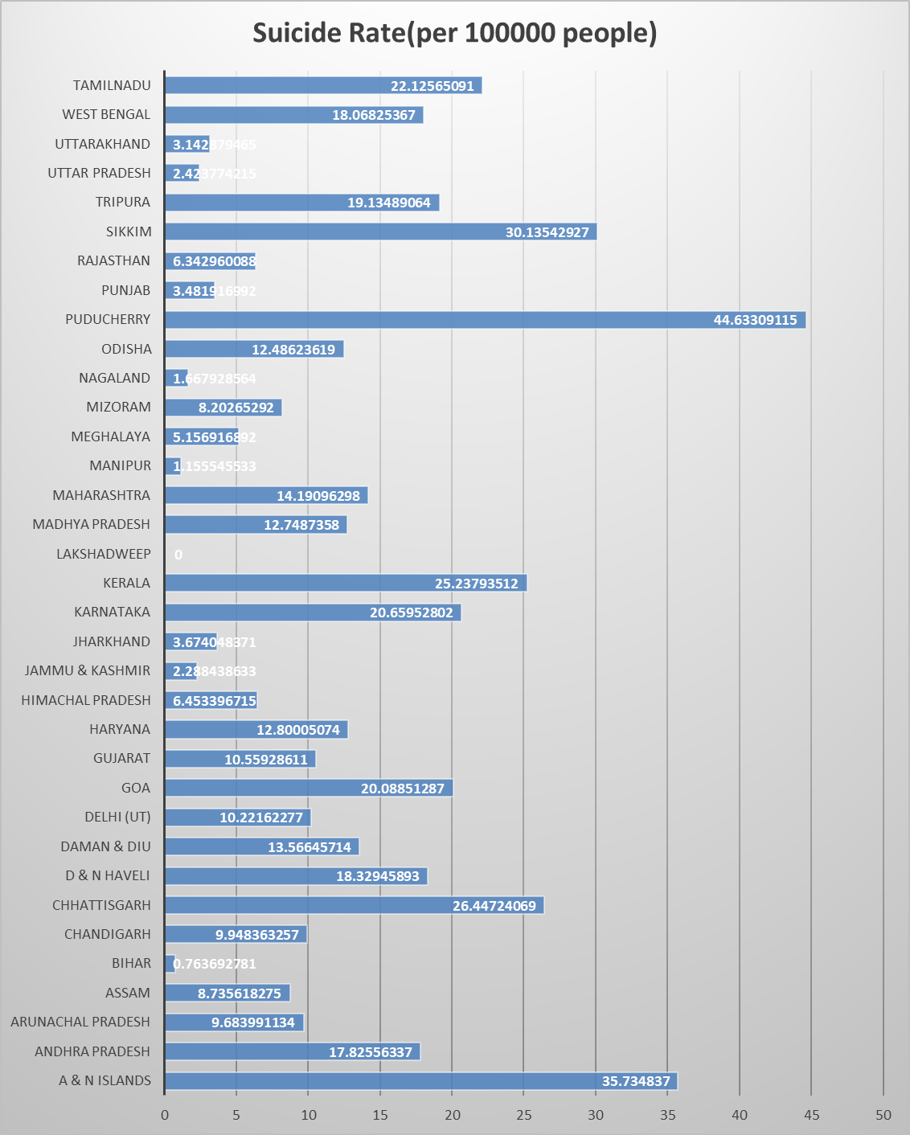

# **GENDER WISE ANALYSIS OF SUICIDE**

Here, from the available data, we want to find out that is there any statistically significant difference between average suicide counts of male and female throughout the years.

|  |  |  |
| --- | --- | --- |
| Year | Female | Male |
| 2001 | 42192 | 66314 |
| 2002 | 41085 | 69332 |
| 2003 | 40630 | 70221 |
| 2004 | 41046 | 72651 |
| 2005 | 40998 | 72916 |
| 2006 | 42410 | 75702 |
| 2007 | 43342 | 79295 |
| 2008 | 44473 | 80544 |
| 2009 | 45680 | 81471 |
| 2010 | 47419 | 87180 |
| 2011 | 47746 | 87839 |
| 2012 | 46992 | 88453 |

To test such hypothesis, we have to use T-test. But there are two types of T-test , one with equal variances and another with unequal variances . To check that the data has equal(or unequal ) variance we will first apply F-test for Two-Sample for variances and then we will apply the T- test according to the result of F-Test .

**F-Test Two-Sample for Variances**

|  |  |
| --- | --- |
| ***H0:*** | *There is no significant differences between the variance.* |
| ***H1 :*** | *There is some significant differences between the variance.* |

|  |  |  |
| --- | --- | --- |
|  | **Female** | **Male** |
| **Mean** | 43667.75 | 77659.83333 |
| **Variance** | 7292523.841 | 58281917.61 |
| **Observations** | 12 | 12 |
| **df** | 11 | 11 |
| **F** | 0.125124981 |  |
| **P(F<=f) one-tail** | 0.000877492 |  |
| **F Critical one-tail** | 0.35487036 |  |

Conclusion

*Null hypothesis is accepted*

*There is no significant differences between the variance.*

Here, from the result of F-Test we got that the variances are equal of both the population set and so we will use the T-Test: Two – Sample Assuming Equal Variances.

**T-Test: Two-Sample Assuming Equal Variances**

*H01: There is no significant difference among two means*

*H11: There is some significant difference among two means*

|  |  |  |
| --- | --- | --- |
|  | **Female** | **Male** |
| **Mean** | 43667.75 | 77659.83333 |
| **Variance** | 7292523.841 | 58281917.61 |
| **Observations** | 12 | 12 |
| **Pooled Variance** | 32787220.72 |  |
| **Hypothesized Mean Difference** | 0 |  |
| **df** | 22 |  |
| **t Stat** | -14.54122873 |  |
| **P(T<=t) one-tail** | 4.58105E-13 |  |
| **t Critical one-tail** | 1.717144374 |  |
| **P(T<=t) two-tail** | 9.16211E-13 |  |
| **t Critical two-tail** | 2.073873068 |  |

Conclusion

*Null hypothesis is rejected*

*There is some significant difference among two means*

From the test result of the T-Test and the graph given above it is clearly evident that there is a major difference among the average count of suicide between male and female. The suicide rate of male is almost double as that of female.

# 3.**Education status vs suicide count**



Here, we want to test whether there is any statistically significant difference between the education status and suicide counts. To test that we will use single factor ANOVA test.

**Anova: Single Factor**

*Ho: There is no significant difference among the suicide count of different education status.*

*H1: There is some significant difference among the suicide count of different education status.*

|  |  |  |  |  |
| --- | --- | --- | --- | --- |
| SUMMARY |  |  |  |  |
| **Groups** | **Count** | **Sum** | **Average** | **Variance** |
| **Diploma** | 12 | 14153 | 1179.416667 | 99164.26515 |
| **Graduate** | 12 | 31274 | 2606.166667 | 677937.2424 |
| **Hr. Secondary** | 12 | 118908 | 9909 | 4078570.545 |
| **Matriculate/Secondary** | 12 | 256566 | 21380.5 | 10048835.73 |
| **Middle(Dropout)** | 12 | 342971 | 28580.91667 | 6459888.447 |
| **No Education** | 12 | 321757 | 26813.08333 | 1014929.538 |
| **Post Graduate and Above** | 12 | 7475 | 622.9166667 | 73192.26515 |
| **Primary** | 12 | 362827 | 30235.58333 | 4749367.356 |

|  |  |  |  |  |  |  |
| --- | --- | --- | --- | --- | --- | --- |
| ANOVA table |  |  |  |  |  |  |
| **Source of Variation** | **SS** | **df** | **MS** | **F** | **P-value** | **F crit** |
| **Between Groups** | 1.409E+10 | 7 | 2012293954 | 591.8101413 | 4.00137E-71 | 2.115471719 |
| **Within Groups** | 299220739 | 88 | 3400235.673 |  |  |  |
|  |  |  |  |  |  |  |
| **Total** | 1.439E+10 | 95 |  |  |  |  |
| **Total** | 1.623E+10 | 107 |  |  |  |  |

Conclusion

*Null hypothesis is rejected*

*There is some significant difference among the suicide count of different education status.*

Here, it is evident from the above test result of ANOVA and graph that the suicide count decreases with increase in education status.

# 4. Age group vs Year wise analysis

Comparison of significant differences among the suicide rate of different year and different age group**.**

|  |  |  |  |  |  |  |  |  |  |  |  |  |
| --- | --- | --- | --- | --- | --- | --- | --- | --- | --- | --- | --- | --- |
| **Age - Group** | **2001** | **2002** | **2003** | **2004** | **2005** | **2006** | **2007** | **2008** | **2009** | **2010** | **2011** | **2012** |
| **0-14** | **3007** | **2880** | **2576** | **2913** | **2555** | **2464** | **2479** | **2381** | **2951** | **3130** | **3035** | **2314** |
| **15-29** | **38910** | **39288** | **39828** | **40136** | **40234** | **42216** | **43160** | **44652** | **43920** | **47625** | **48014** | **41793** |
| **30-44** | **36448** | **37512** | **37017** | **38296** | **38183** | **40699** | **41832** | **43562** | **43488** | **44846** | **46215** | **40615** |
| **45-59** | **21579** | **21857** | **22332** | **23139** | **23625** | **23606** | **25571** | **25192** | **26603** | **27889** | **27536** | **25404** |
| **60+** | **8562** | **8880** | **9098** | **9213** | **9317** | **9127** | **9595** | **9230** | **10189** | **11109** | **10785** | **10362** |

*Ho1: There is no significant difference among the suicide count of different age group.*

*H11: There is some significant difference among the suicide count of different age group.*

*Ho2: There is no significant difference among the suicide count of different years.*

*H12: There is some significant difference among the suicidecount of different years***.**

**Anova: Two-Factor Without Replication**

|  |  |  |  |  |
| --- | --- | --- | --- | --- |
| *SUMMARY* | *Count* | *Sum* | *Average* | *Variance* |
| 0-14 | 12 | 32685 | 2723.75 | 83370.02273 |
| 15-29 | 12 | 509776 | 42481.333 | 9581557.152 |
| 30-44 | 12 | 488713 | 40726.083 | 10797350.63 |
| 45-59 | 12 | 294333 | 24527.75 | 4654018.386 |
| 60+ | 12 | 115467 | 9622.25 | 640117.2955 |
|  |  |  |  |  |
| 2001 | 5 | 108506 | 21701.2 | 258934382.7 |
| 2002 | 5 | 110417 | 22083.4 | 269297889.8 |
| 2003 | 5 | 110851 | 22170.2 | 271766659.2 |
| 2004 | 5 | 113697 | 22739.4 | 280214702.3 |
| 2005 | 5 | 113914 | 22782.8 | 283227876.2 |
| 2006 | 5 | 118112 | 23622.4 | 323781752.3 |
| 2007 | 5 | 122637 | 24527.4 | 339205144.3 |
| 2008 | 5 | 125017 | 25003.4 | 372774453.8 |
| 2009 | 5 | 127151 | 25430.2 | 351735228.7 |
| 2010 | 5 | 134599 | 26919.8 | 391732320.7 |
| 2011 | 5 | 135585 | 27117 | 412067680.5 |
| 2012 | 5 | 120488 | 24097.6 | 312712575.3 |

ANOVA table

|  |  |  |  |  |  |  |
| --- | --- | --- | --- | --- | --- | --- |
| ***Source of Variation*** | **SS** | **df** | **MS** | **F** | **P-value** | **F crit** |
| **Rows** | 15371967084 | 4 | 3.843E+09 | 1728.324603 | 9.58E-48 | 2.583667 |
| **Columns** | 185484969.5 | 11 | 16862270 | 7.583538496 | 4.06E-07 | 2.014046 |
| **Error** | 97835578.8 | 44 | 2223535.9 |  |  |  |
|  |  |  |  |  |  |  |
| **Total** | 15655287633 | 59 |  |  |  |  |

Conclusion for Age Group

*Null hypothesis is rejected*

*There is some significant difference among the suicide count of different age group.*

Conclusion for the Years

*Null hypothesis is rejected*

*There is some significant difference among the suicide count of different years.*

# **AGE GROUP VS. SUCIDE CAUSES**

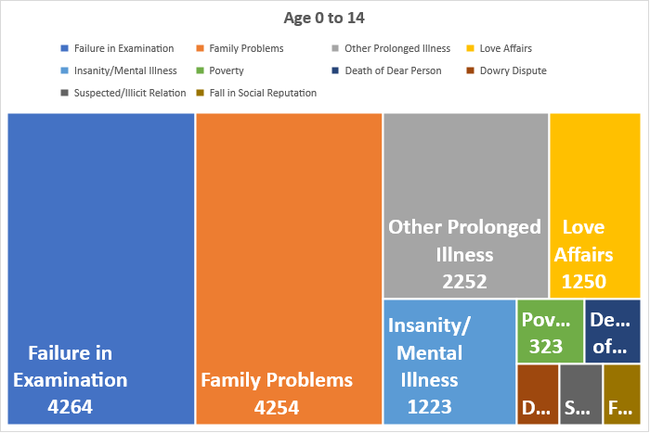

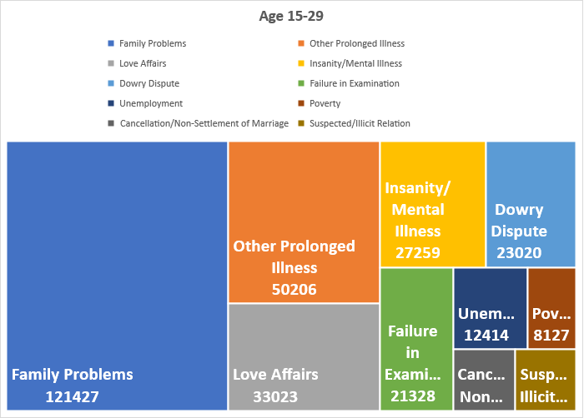

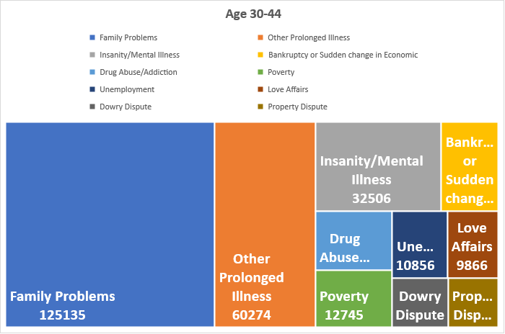

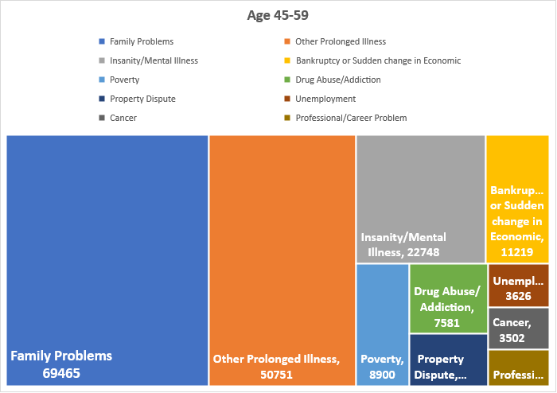

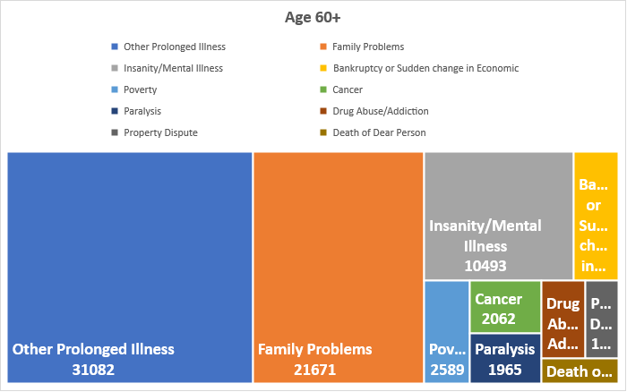

|  |  |  |  |  |  |
| --- | --- | --- | --- | --- | --- |
| ***CAUSES*** | ***0-14*** |  | ***CAUSES*** | | ***15-29*** |
| Failure in Examination | **4264** |  | Family Problems | **121427** | |
| Family Problems | 4254 |  | Other Prolonged Illness | 50206 | |
| Other Prolonged Illness | 2252 |  | Love Affairs | 33023 | |
| Love Affairs | 1250 |  | Insanity/Mental Illness | 27259 | |
| Insanity/Mental Illness | 1223 |  | Dowry Dispute | 23020 | |
| Poverty | 323 |  | Failure in Examination | 21328 | |
| Death of Dear Person | 267 |  | Unemployment | 12414 | |
| Dowry Dispute | 191 |  | Poverty | 8127 | |
| Suspected/Illicit Relation | 191 |  | Cancellation/Non-Settlement of Marriage | 7703 | |
| Fall in Social Reputation | 169 |  | Suspected/Illicit Relation | 7565 | |
| Bankruptcy or Sudden change in Economic | 124 |  | Drug Abuse/Addiction | 7378 | |
| Physical Abuse (Rape/Incest Etc.) | 120 |  | Bankruptcy or Sudden change in Economic | 6265 | |
| Drug Abuse/Addiction | 114 |  | Fall in Social Reputation | 4719 | |
| Illness (Aids/STD) | 105 |  | Property Dispute | 4333 | |
| Unemployment | 91 |  | Professional/Career Problem | 3478 | |
| Paralysis | 70 |  | Death of Dear Person | 3420 | |
| Illegitimate Pregnancy | 67 |  | Not having Children (Barrenness/Impotency | 3097 | |
| Property Dispute | 66 |  | Illness (Aids/STD) | 2414 | |
| Cancellation/Non-Settlement of Marriage | 49 |  | Physical Abuse (Rape/Incest Etc.) | 2065 | |
| Cancer | 34 |  | Illegitimate Pregnancy | 1702 | |
| Ideological Causes/Hero Worshipping | 34 |  | Divorce | 1552 | |
| Professional/Career Problem | 32 |  | Paralysis | 1051 | |
| Not having Children (Barrenness/Impotency | 31 |  | Cancer | 922 | |
| Divorce | 5 |  | Ideological Causes/Hero Worshipping | 825 | |
|  |  |  |  |  | |
|  |  |  |  |  | |
| ***CAUSES*** | ***30-44*** |  | ***CAUSES*** | ***45-59*** | |
| Family Problems | **125135** |  | Family Problems | **69465** | |
| Other Prolonged Illness | 60274 |  | Other Prolonged Illness | 50751 | |
| Insanity/Mental Illness | 32506 |  | Insanity/Mental Illness | 22748 | |
| Bankruptcy or Sudden change in Economic | 14675 |  | Bankruptcy or Sudden change in Economic | 11219 | |
| Drug Abuse/Addiction | 13123 |  | Poverty | 8900 | |
| Poverty | 12745 |  | Drug Abuse/Addiction | 7581 | |
| Unemployment | 10856 |  | Property Dispute | 5624 | |
| Love Affairs | 9866 |  | Unemployment | 3626 | |
| Dowry Dispute | 8098 |  | Cancer | 3502 | |
| Property Dispute | 7204 |  | Professional/Career Problem | 3043 | |
| Suspected/Illicit Relation | 5663 |  | Fall in Social Reputation | 2809 | |
| Professional/Career Problem | 5441 |  | Paralysis | 2409 | |
| Fall in Social Reputation | 4963 |  | Death of Dear Person | 2204 | |
| Not having Children (Barrenness/Impotency | 4056 |  | Illness (Aids/STD) | 1863 | |
| Illness (Aids/STD) | 3503 |  | Suspected/Illicit Relation | 1358 | |
| Death of Dear Person | 3364 |  | Not having Children (Barrenness/Impotency | 1269 | |
| Cancellation/Non-Settlement of Marriage | 3055 |  | Love Affairs | 862 | |
| Cancer | 2538 |  | Dowry Dispute | 629 | |
| Divorce | 1904 |  | Divorce | 615 | |
| Paralysis | 1791 |  | Cancellation/Non-Settlement of Marriage | 439 | |
| Failure in Examination | 1254 |  | Physical Abuse (Rape/Incest Etc.) | 430 | |
| Physical Abuse (Rape/Incest Etc.) | 1239 |  | Ideological Causes/Hero Worshipping | 425 | |
| Ideological Causes/Hero Worshipping | 723 |  | Failure in Examination | 145 | |
| Illegitimate Pregnancy | 654 |  | Illegitimate Pregnancy | 69 | |
|  |  |  |  |  | |
|  |  |  |  |  | |
|  |  |  |  |  | |
|  |  |  |  |  | |
|  |  |  |  |  | |
| ***CAUSES*** | ***60+*** |  |  |  | |
| Other Prolonged Illness | **31082** |  |  |  | |
| Family Problems | 21671 |  |  |  | |
| Insanity/Mental Illness | 10493 |  |  |  | |
| Bankruptcy or Sudden change in Economic | 3127 |  |  |  | |
| Poverty | 2589 |  |  |  | |
| Cancer | 2062 |  |  |  | |
| Paralysis | 1965 |  |  |  | |
| Drug Abuse/Addiction | 1850 |  |  |  | |
| Property Dispute | 1425 |  |  |  | |
| Death of Dear Person | 1066 |  |  |  | |
| Illness (Aids/STD) | 838 |  |  |  | |
| Fall in Social Reputation | 804 |  |  |  | |
| Professional/Career Problem | 560 |  |  |  | |
| Unemployment | 378 |  |  |  | |
| Physical Abuse (Rape/Incest Etc.) | 138 |  |  |  | |
| Not having Children (Barrenness/Impotency | 135 |  |  |  | |
| Suspected/Illicit Relation | 134 |  |  |  | |
| Ideological Causes/Hero Worshipping | 111 |  |  |  | |
| Divorce | 57 |  |  |  | |
| Cancellation/Non-Settlement of Marriage | 50 |  |  |  | |
| Love Affairs | 38 |  |  |  | |
| Dowry Dispute | 32 |  |  |  | |
| Failure in Examination | 14 |  |  |  | |
| Illegitimate Pregnancy | 2 |  |  |  | |

Now, from the above tables and graphs we observe that the major reason behind the suicide among the age group of:-

0-14: Failure in Examination

15-60: Family Problem

Above 60: Prolonged illness

Here, we have observed that for a prominent group of population the reason behind suicide is “Family Problem”. But how much in terms of percentage does this cause affect the suicide?

# **5. CAUSES VS. SUICIDE**

|  |  |
| --- | --- |
| **Causes** | **Total suicide** |
| Family Problems | 341952 |
| Insanity/Mental Illness | 94229 |
| Love Affairs | 45039 |
| Bankruptcy or Sudden change in Economic | 32755 |
| Poverty | 32684 |
| Dowry Dispute | 31970 |
| Drug Abuse/Addiction | 30046 |
| Unemployment | 27365 |
| Failure in Examination | 27005 |
| Property Dispute | 18652 |
| Suspected/Illicit Relation | 14911 |
| Fall in Social Reputation | 13464 |
| Professional/Career Problem | 12554 |
| Cancellation/Non-Settlement of Marriage | 11296 |
| Death of Dear Person | 10321 |
| Cancer | 9058 |
| Illness (Aids/STD) | 8723 |
| Not having Children(Barrenness/Impotency | 7822 |
| Paralysis | 7286 |
| Divorce | 4133 |
| Physical Abuse (Rape/Incest Etc.) | 3992 |
| Bankruptcy or Sudden change in Economic Status | 2655 |
| Illegitimate Pregnancy | 2494 |
| Ideological Causes/Hero Worshipping | 2118 |
| Not having Children (Barrenness/Impotency | 766 |

**50% of Suicides in India are committed due to FAMILY PROBLEMS.**

# **6. STATE WISE CAUSES**

|  |  |  |  |  |  |
| --- | --- | --- | --- | --- | --- |
| **Sr.no** | **States** | **Total Suicide** | **Percentage** | **CAUSE** | **SUICIDE COUNT** |
| 1 | Maharashtra | 180389 | 12.52% | Family Problems | 65341 |
| 2 | Tamil Nadu | 163813 | 11.37% | Family Problems | 49663 |
| 3 | Andhra Pradesh | 162820 | 11.30% | Other Prolonged Illness | 33836 |
| 4 | West Bengal | 161030 | 11.18% | Family Problems | 35885 |
| 5 | Karnataka | 146965 | 10.20% | Other Prolonged Illness | 31625 |
| 6 | Kerala | 107936 | 7.49% | Family Problems | 36327 |
| 7 | Madhya Pradesh | 90307 | 6.27% | Family Problems | 18281 |
| 8 | Gujarat | 66177 | 4.59% | Family Problems | 13057 |
| 9 | Chhattisgarh | 60495 | 4.20% | Family Problems | 8066 |
| 10 | Odisha | 53448 | 3.71% | Family Problems | 11924 |
| 11 | Rajasthan | 51027 | 3.54% | Family Problems | 11430 |
| 12 | Uttar Pradesh | 46680 | 3.24% | Family Problems | 9733 |
| 13 | Assam | 34469 | 2.39% | Love Affairs | 4852 |
| 14 | Haryana | 29437 | 2.04% | Family Problems | 5045 |
| 15 | Delhi (Ut) | 16857 | 1.17% | Family Problems | 4105 |
| 16 | Jharkhand | 9950 | 0.69% | Family Problems | 1146 |
| 17 | Punjab | 9270 | 0.64% | Insanity/Mental Illness | 2182 |
| 18 | Bihar | 9245 | 0.64% | Family Problems | 1824 |
| 19 | Tripura | 9194 | 0.64% | Family Problems | 2743 |
| 20 | Puducherry | 6429 | 0.45% | Family Problems | 2724 |
| 21 | Himachal Pradesh | 5319 | 0.37% | Family Problems | 1144 |
| 22 | Uttarakhand | 3702 | 0.26% | Family Problems | 862 |
| 23 | Goa | 3475 | 0.24% | Insanity/Mental Illness | 602 |
| 24 | Jammu & Kashmir | 2968 | 0.21% | Family Problems | 426 |
| 25 | Sikkim | 1924 | 0.13% | Insanity/Mental Illness | 291 |
| 26 | A & N Islands | 1623 | 0.11% | Other Prolonged Illness | 341 |
| 27 | Arunachal Pradesh | 1328 | 0.09% | Family Problems | 96 |
| 28 | Meghalaya | 1086 | 0.08% | Family Problems | 180 |
| 29 | Chandigarh | 1034 | 0.07% | Family Problems | 303 |
| 30 | Mizoram | 834 | 0.06% | Drug Abuse/Addiction | 112 |
| 31 | D & N Haveli | 686 | 0.05% | Family Problems | 187 |
| 32 | Manipur | 421 | 0.03% | Family Problems | 26 |
| 33 | Nagaland | 347 | 0.02% | Family Problems | 26 |
| 34 | Daman & Diu | 279 | 0.02% | Insanity/Mental Illness | 17 |
| 35 | Lakshadweep | 10 | 0.00% | Insanity/Mental Illness | 3 |

*Frequency of causes*

|  |  |
| --- | --- |
| Family Problem | 25 |
| Insanity/Mental Illness | 5 |
| Other Prolonged Illness | 3 |
| Love Affairs | 1 |
| Drug Abuse | 1 |

# **Conclusion:**

We have observed that the states with major cause of suicide as “insanity or mental illness” are Punjab, Goa, Sikkim, Diu Daman and Lakshadweep.

Here, all these states (except Lakshadweep) have very high consumption of drugs and alcohol. So, to reduce suicide rate in these states it is necessary to reduce the consumption of alcohol and drugs in these states.

The data shows significant relation between consumption of drugs and alcohol and suicide counts due to mental illness or insanity.

# 7. **PROFESSION VS. SUICIDE**

# **8.SOCIAL STATUS VS. SUCIDE**

|  |  |
| --- | --- |
| **Social Status** | **No.of Suicide** |
| Divorcee | 15272 |
| Married | 1021774 |
| Never Married | 318301 |
| Separated | 38471 |
| Widowed/Widower | 62113 |

# 9.FORECASTING BASED ON TRENDLINE

Here we have the suicide data of year 2001 to 2012. But we are interested in forecasting future suicide counts.

Let’s predict the future values using our predictive model on the available data.

|  |  |
| --- | --- |
| YEARS | Sum of Total |
| 2001 | 108506 |
| 2002 | 110417 |
| 2003 | 110851 |
| 2004 | 113697 |
| 2005 | 113914 |
| 2006 | 118112 |
| 2007 | 122637 |
| 2008 | 125017 |
| 2009 | 127151 |
| 2010 | 134599 |
| 2011 | 135585 |
| 2012 | 135445 |

|  |  |
| --- | --- |
| Forecasted | |
| 2012 | 137083 |
| 2013 | 139923 |
| 2014 | 142763 |
| 2015 | 145603 |

Final conclusion

* India has highest number of suicide rate in female.
* The suicide rate of ***male is almost double as that of female***.
* The suicide count ***decreases*** with ***increase in education status***.
* The major reason behind the suicide among the age group of:-

***0-14: Failure in Examination***

***15-60: Family Problem***

***Above 60: Prolonged illness***

* ***50%*** of Suicides in India are committed due to ***FAMILY PROBLEMS***.
* We have observed that the states with major cause of suicide as **“insanity or mental illness**” ***are Punjab, Goa, Sikkim, Diu Daman and Lakshadweep.***

Here, all these states (except Lakshadweep) have ***very high consumption of drugs and alcohol***. So, to reduce suicide rate in these states it is necessary to reduce the consumption of alcohol and drugs in these states.

The data shows significant relation between consumption of drugs and alcohol and suicide counts due to mental illness or insanity.

* According to profession, ***Housewives*** and ***farmers*** commit ***highest*** and ***second-highest*** suicide respectively.
* Suicide in ***Private sector*** is almost ***10 folds*** to that in ***Public sector*** employees.
* According to Social Status, among all suicide committers,**70%** are ***MARRIED***

Sources:

Data: Secondary data extracted from KAGGLE

Population data: official census website

Graphs: WHO.int

### Acknowledgements

National Crime Records Bureau (NCRB), Govt of India has shared this [dataset](https://data.gov.in/dataset-group-name/accidental-deaths-and-suicides) under [Govt. Open Data License - India](https://data.gov.in/government-open-data-license-india).

Tools:

Ms Excel

Ms Word

Tableau

*Thank you*